Lab Exercise Report 1
Student Name: Nguyễn Việt Hoàng
Student ID: B22DCVT214
Date of Submission: 22/09/2025

Problem 1 (50 points):
Proof that your my can run:
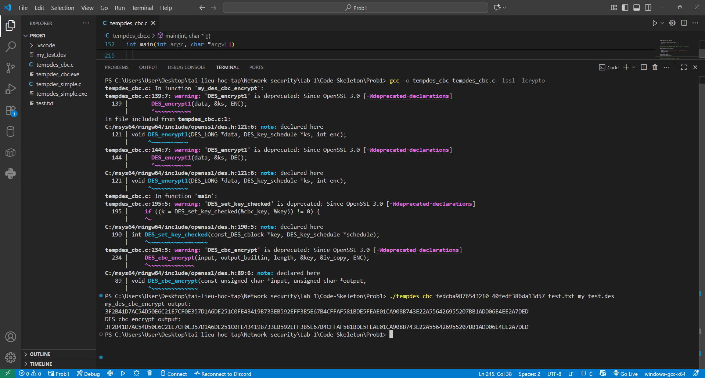

Problem 2 (50 points):
Proof that your my can run:
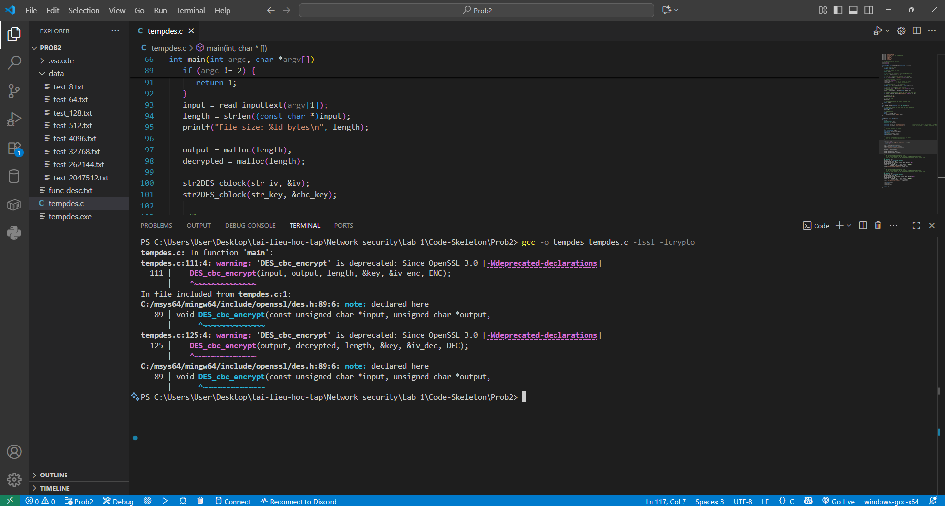
- 8 bytes file:
  - 1st run:
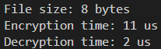
  - 2nd run:
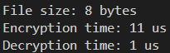
  - 3rd run:
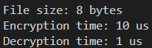
  - 4th run:
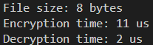
  - 5th run:
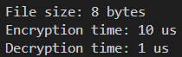
Average Encryption time: 10.6 µs
Average Decryption time: 1.4 µs
- 64 bytes files:
  - 1st run:
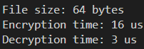
  - 2nd run:
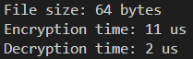
  - 3rd run:
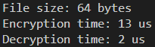
  - 4th run:
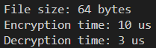
  - 5th run:
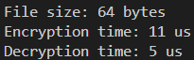
Average Encryption time: 12.2 µs
Average Decryption time: 3 µs
- 128 bytes files:
  - 1st run:
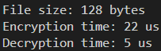
  - 2nd run:
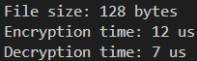
  - 3rd run:
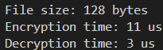
  - 4th run:
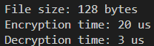
  - 5th run:
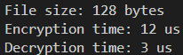
Average Encryption time: 15.4 µs
Average Decryption time: 4.2 µs
- 512 bytes files:
  - 1st run:
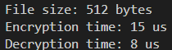
  - 2nd run:
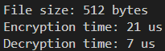
  - 3rd run:
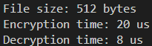
  - 4th run:
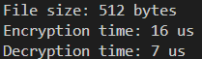
  - 5th run:
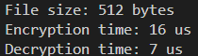
Average Encryption time: 17.6 µs
Average Decryption time: 7.4 µs
- 4096 bytes files:
  - 1st run:
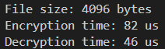
  - 2nd run:
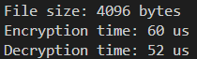
  - 3rd run:
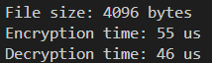
  - 4th run:
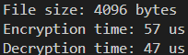
  - 5th run:
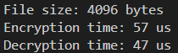
Average Encryption time: 62.2 µs
Average Decryption time: 47.6 µs
- 32768 bytes files:
  - 1st run:
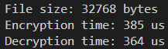
  - 2nd run:
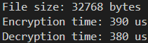
  - 3rd run:
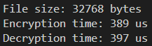
  - 4th run:
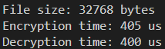
  - 5th run:
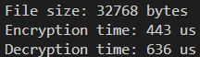
Average Encryption time: 402.4 µs
Average Decryption time: 435.4 µs
- 262144 bytes files:
  - 1st run:
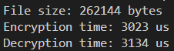
  - 2nd run:
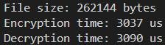
  - 3rd run:
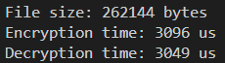
  - 4th run:
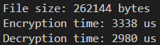
  - 5th run:
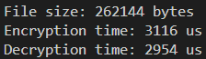
Average Encryption time: 3122 µs
Average Decryption time: 2841.4 µs
- 2047512 bytes files:
  - 1st run:
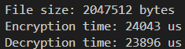
  - 2nd run:
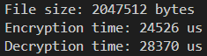
  - 3rd run:
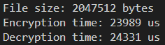
  - 4th run:
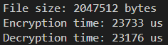
  - 5th run:
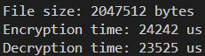
Average Encryption time: 24106.6 µs
Average Decryption time: 24659.6 µs
Make graphs of the time measurements [μs] as function of file sizes [bytes]

